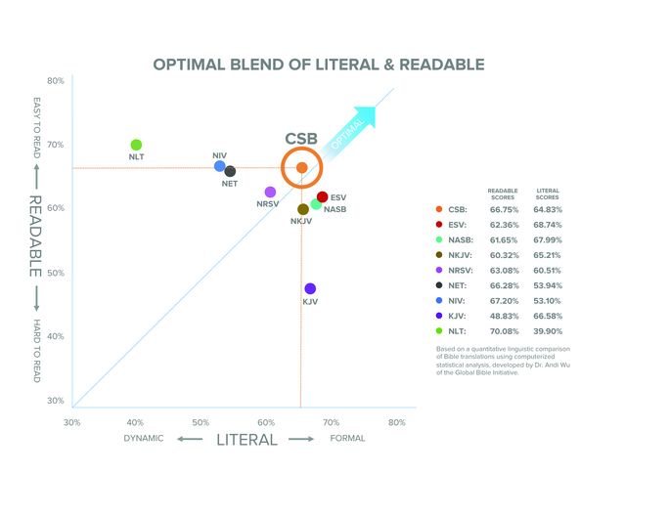
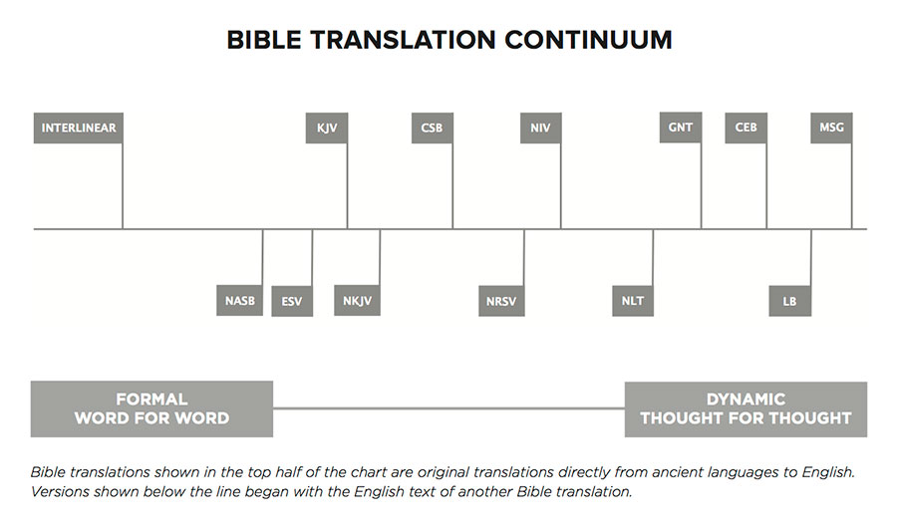

Translation | Reading Level
King James | 12
New American | 10
New King James | 7
New International | 7
CSB | 7
New Living (NLT) | 6
Contemporary Eng | 5

